**DESCRIPTION**:

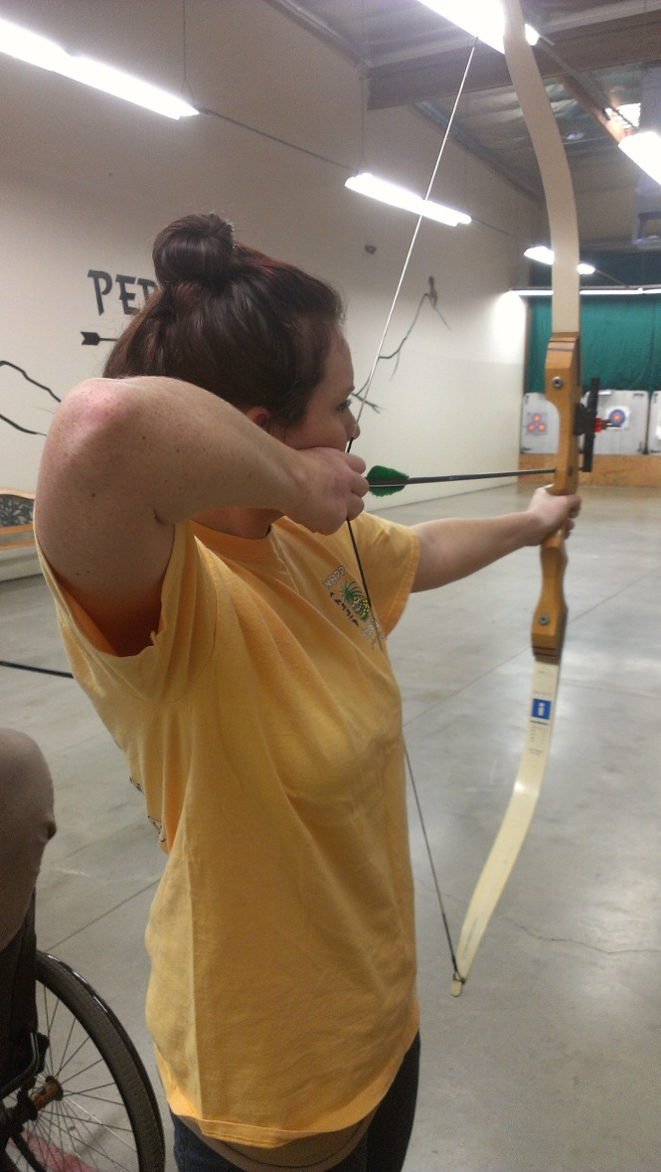

|  |  |
| --- | --- |
| **Description** | **Analysis** |
| The archer’s target is in her line of sight. | Attention allocation - The archer’s attention lies solely on the center of the target. She focuses through the sight. |
| The archer stands perpendicularly to the target. | Common practice and technique |
| The target (seen in the background) has different colored rings. | Coding scheme – color coding related to accuracy rating and point values. Highlighting – the yellow center is the most salient. Articulation of graphic representation – the target is only a diagram that sets a goal during practice. (Goodwin) |
| The archer’s hair is pulled back from her face. | Epistemic action that enables the archer to move freely. (Williams) |
| The archer’s arm is right arm pulled straight back, extended from the arrow. | Common practice and technique (archer’s repertoire). Forms a relationship between archer and arrow that follows through the line of sight to the target. Arrow is an extension of the archer’s arm and self. |
| Various elements – the grooves on the floor, the strip lights on the ceiling, etc. form a perspective. |  |
| Muscle Memory | Past experience via practice plays a role in present and future activity (Neisser) – The form she learned in the expert-guided scaffolding is repeated in her later attempts and will most likely continue to repeat in her future attempts. |
|  |  |

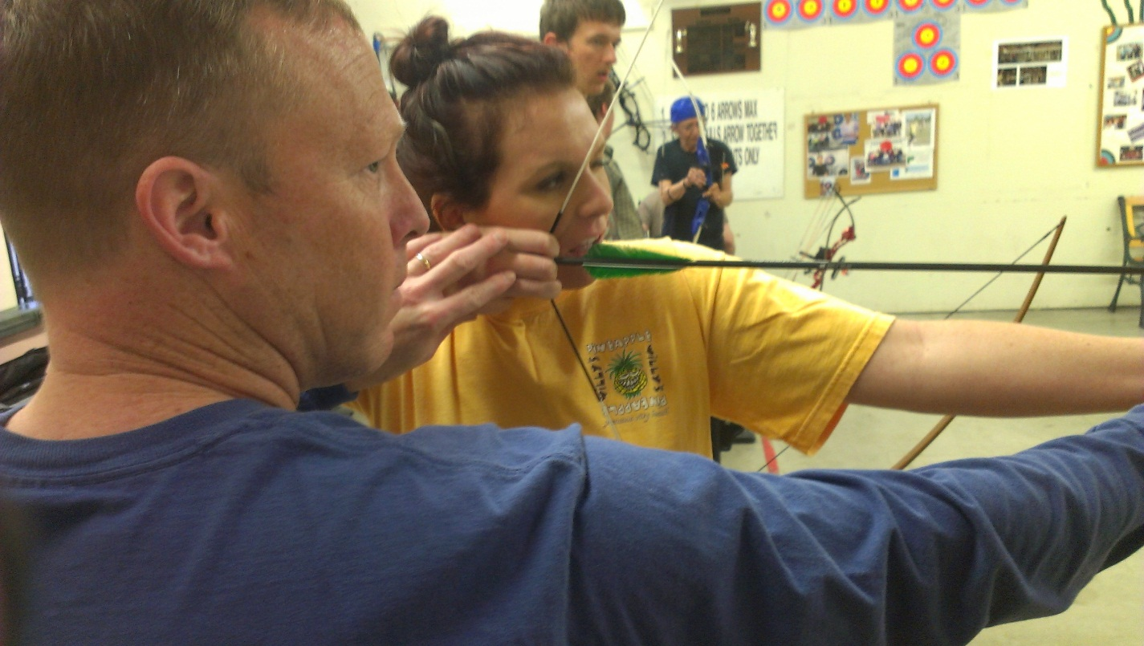

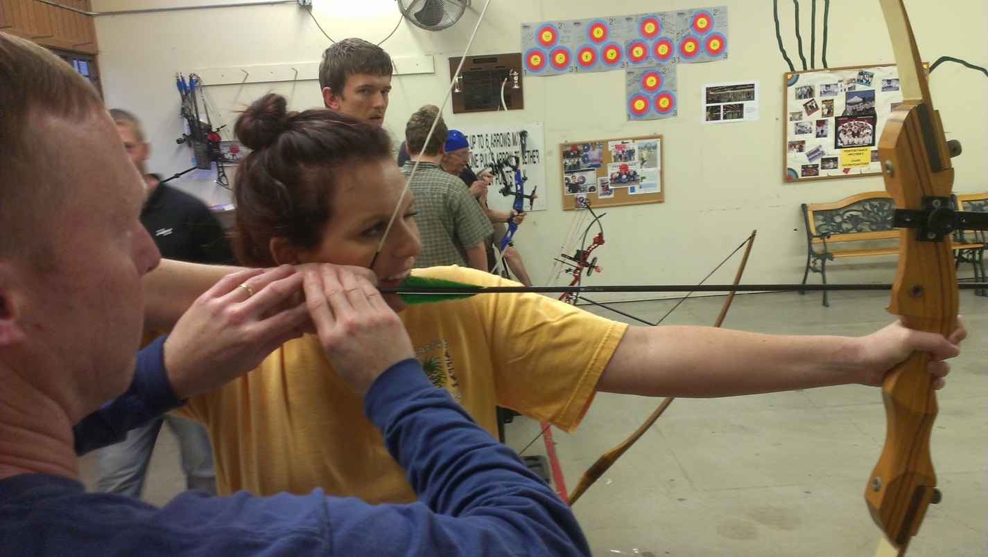

|  |  |
| --- | --- |
| **Observation** | **Cognitive Significance** |
| The ‘expert’ adjusts the archer’s grip to a particular spot on her face. | Encourages repetition in style of shooting. This gives the archer a |
| The archer keeps one eye closed |  |
| The archer’s line of position is parallel to her neighbors’ projected lines of position | Acceptable practice in the arena (archery range) to ensure safety. (Lave) A red line is clearly marked on the floor to highlight where the archers are to stand. |
| The archer uses three fingers around the nock (part where the arrow reaches the bowstring) |  |
| The archer uses a predefined wooden grip that is contoured for right-handed archers |  |

Analysis:

Professional Vision

Domain of Scrutiny: practices used by members of a profession to shape events in the phenomenal environment they focus their attention on.

Discursive practices – coding schemes, highlighting, articulation of graphic representations to divide the domain of scrutiny.

Cognition is more than just perception and action. It’s the conditional change in sensory-motor activity - **the adaptiveness of behavior** - that characterizes an event as cognitive. (Johnson)